Industrial microbiology lab

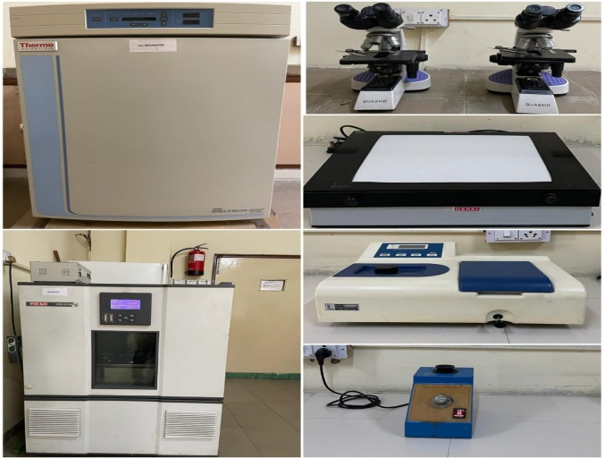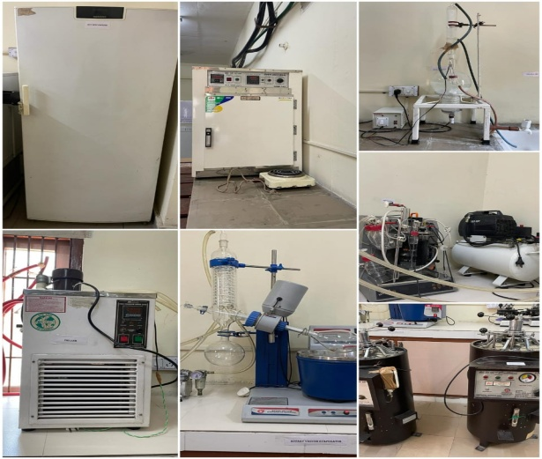

1 -20 deep refrigerator

2 oven

3 water distillation unit

4 Chiller

5 Rotatory vacuum evaporator

6 Bioreactor

7 Autoclave

8 CO2 incubator

9 Microscope

10 UV reader

11 Incubator shaker

12 spectrophotometer

13 vortex shaker

|  |
| --- |
| Plant Tissue Culture Lab |

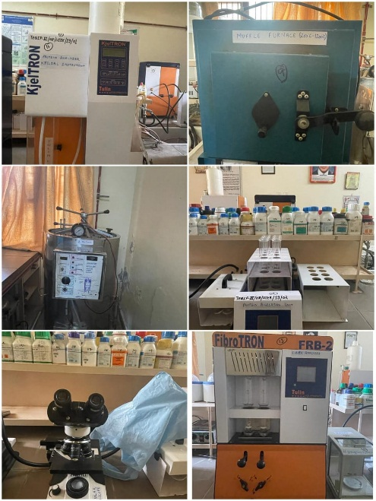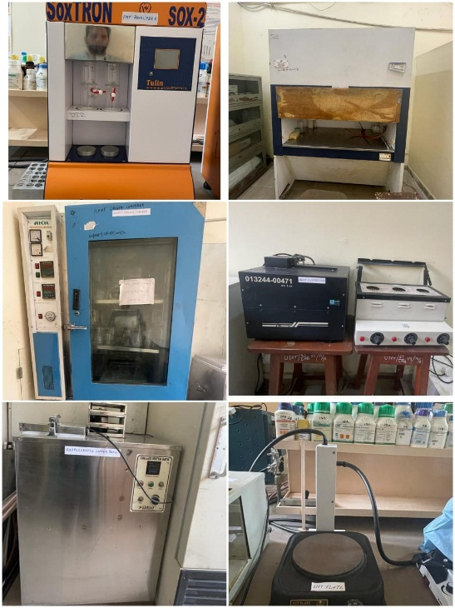

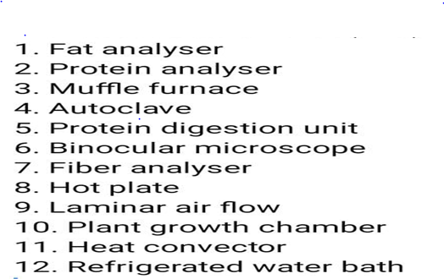

|  |
| --- |
| Medicial Plant Biotechnology Lab |

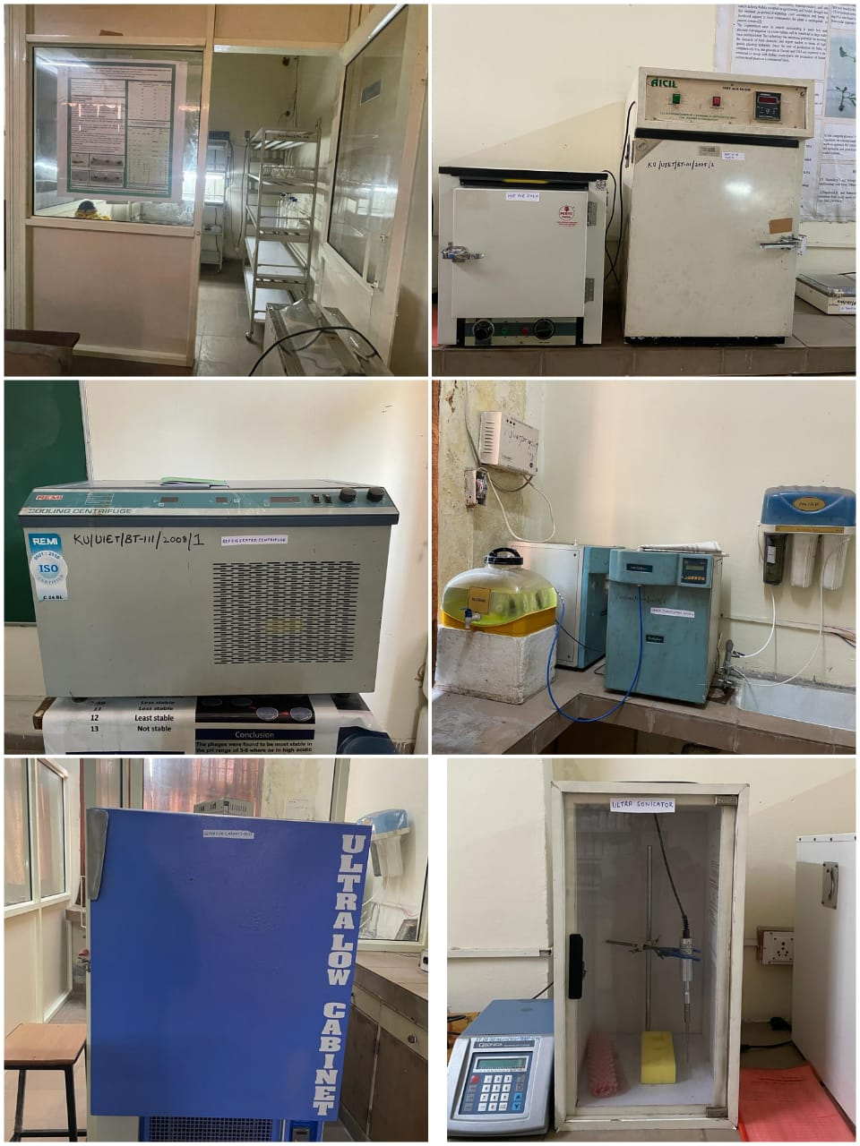

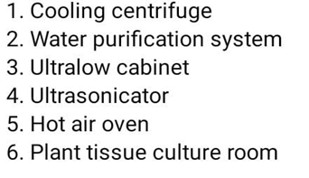

Fermentation lab

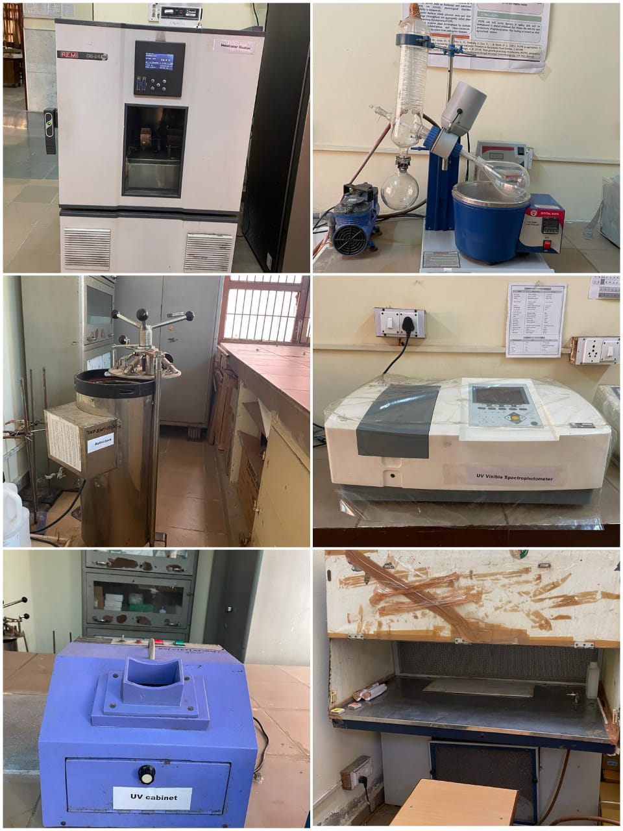

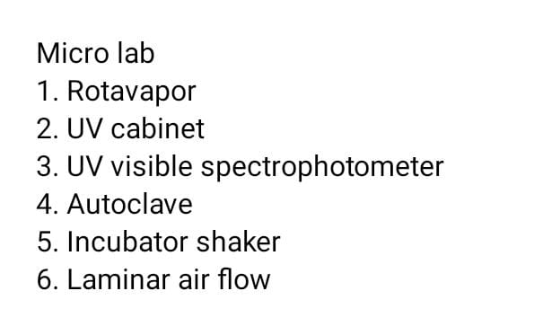

|  |
| --- |
| rDNA Lab |

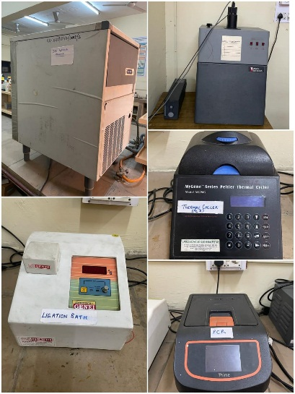

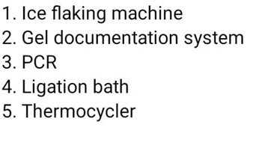

Biochemistry lab

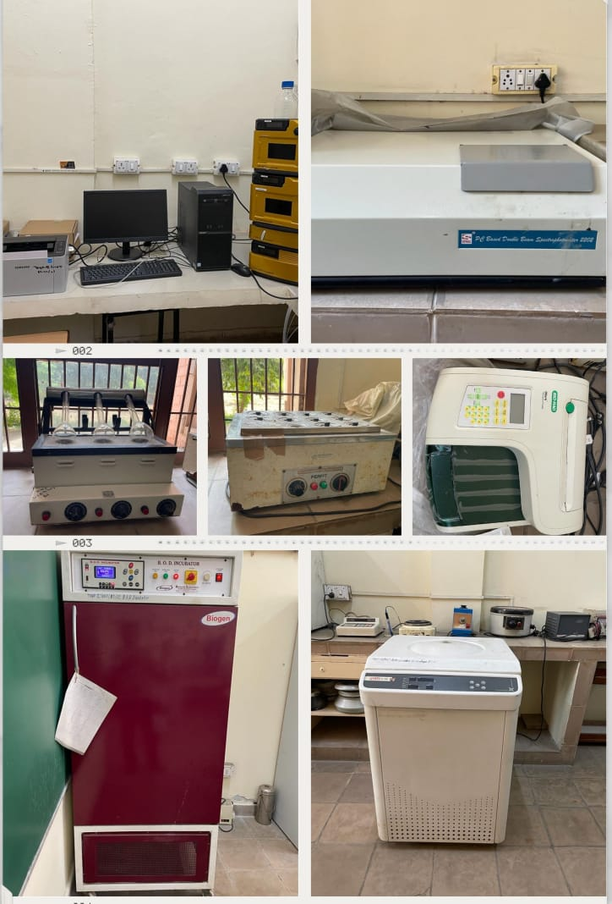

|  |
| --- |
| 1. Water Bath  2. PC Based Double Beam Spectrophotometer  3. HPLC  4. Refrigerator Centrifuge  5. BOD Incubator  6. Micro plate reader |

|  |
| --- |
| Bioinformatics lab |

